Ideation Phase

Define the Problem Statements

|  |  |
| --- | --- |
| Date | 18 OCTOBER 2022 |
| Team ID | PNT2022TMID18845 |
| Project Name | IoT Based Safety Gadget for Child Safety Monitoring & Notification |
| Maximum Marks | 2 Marks |

# Example:

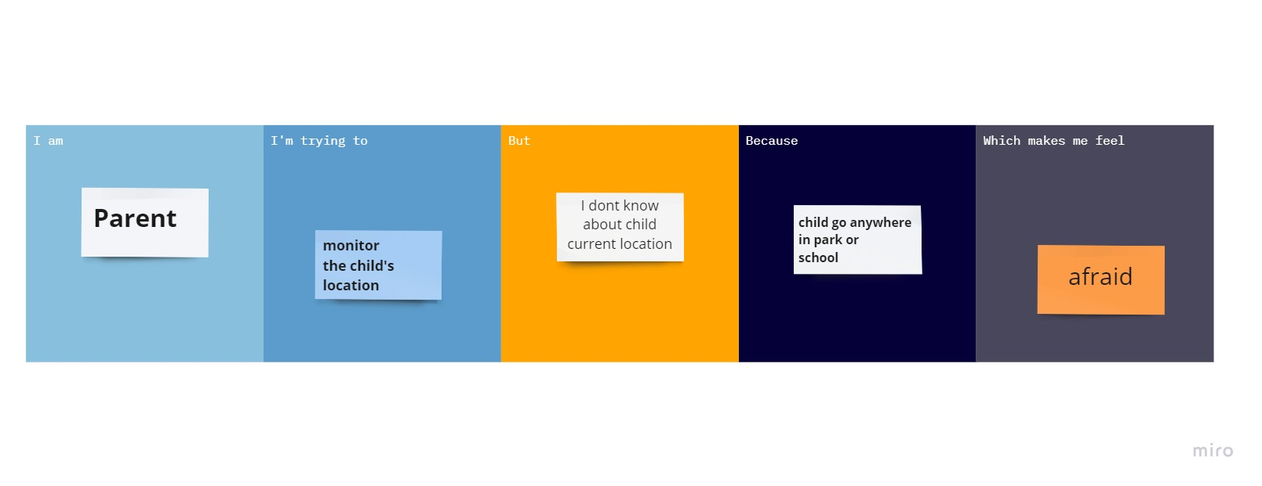

|  |  |  |  |  |  |
| --- | --- | --- | --- | --- | --- |
| **Problem**  **Statement (PS)** | **I am**  **(Customer)** | **I’m trying to** | **But** | **Because** | **Which makes me feel** |
| PS-1 | parent | Monitor the  Child’s location | I don’t Know  About the child current location | Child go anywhere in park or school | Afraid |
| PS-2 | parent | I am trying to keep my child in circumference | By using geofence we monitor child location | There may be missing of child from parents view | Afraid again using geofence we can locate the child |